**Drill 2**

**Objective:**

Ensure learners can successfully set up their data science environment, use RStudio to write and execute R scripts, and organize their work systematically within their GitHub repository.

**Instructions:**

**1. Install R and RStudio**

* Confirm that R and RStudio are installed on your computer.
* If they are not installed, download and install them from their official websites:
  + **R**: <https://cran.r-project.org/>
  + **RStudio**: <https://posit.co/products/open-source/rstudio/>
* **Important Note**: If you do not have the necessary permissions to install software on your computer, seek assistance from your IT department or the appropriate personnel to ensure the installation is completed successfully.

**2. Create an R Project for the Repository**

* Open RStudio.
* Go to **File > New Project**.
* Select **Existing Directory** as the option for the project.
* Browse to the local folder for your GitHub repository (data-science-specialization), which you created in Drill 1.
* Click **Create Project**.
* Your project is now configured, and all files and folders in the repository will be accessible within RStudio.

**3. Write Your First R Script**

* Open RStudio and create a new R script.
* In the script, include the following tasks:
  + **Print a welcoming message**:
    - Print a message like "Welcome to the Data Science Specialization!".
  + **Create a simple data frame**:
    - The data frame should have at least three columns (e.g., Name, Age, and Profession) and at least two rows.
  + **Display the data frame**:
    - Use the print() function to display the data frame in the R console.

**Note**:  
Although you may not have explicitly been shown how to create a data frame or display it in the console, you are expected to take charge of your learning experience. This means intentionally stepping outside of what has been taught and learning new things on your own. Use resources such as the R Documentation, RStudio’s help feature, or online tutorials to figure out how to complete these tasks. **DO NOT USE AI.**

**4. Save the Script**

Save your R script as intro_script.R inside the existing 01-the-data-scientists-toolbox/drills folder.

**5. Use Git for Version Control**

* Open **GitHub Desktop** and ensure it is pointing to your cloned repository.
* **Stage the changes**:
  + GitHub Desktop will detect the new file intro_script.R in the drills folder as "Uncommitted Changes."
  + Review the changes.
* **Commit the changes**:
  + Use the following **commit message template**:
    - **Summary (First Line)**: *The Data Scientist's Toolbox - Added intro_script.R*
    - **Longer Message (Optional)**: *Added intro_script.R to the drills folder in The Data Scientist's Toolbox course. This script includes a welcoming message, a simple data frame creation, and the data frame is displayed in the console as part of Drill 2.*
* After committing the changes, click the **Push Origin** button in GitHub Desktop to upload the changes to your online repository.

**6. Submit the Repository**

* Verify that your online repository now includes the following structure:

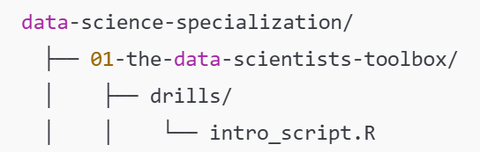

* Submit the **URL to your GitHub repository** for grading.

**Important Notes:**

1. **No Use of ChatGPT or other AI Tools**:
   * Complete the task independently without the assistance of AI tools.
2. **Collaboration Allowed**:
   * You may share or discuss solutions with peers.
3. **Grading Criteria**:
   * The repository structure is correct, and the script file (intro_script.R) exists in the correct location.
   * The R script runs without errors and produces the expected outputs.
   * Commit messages are clear and meaningful.
   * Changes are successfully pushed to GitHub.